An Evolutionary Neural Network for Classification

Looth Mohamed | S1600582

1 INTRODUCTION
This report explains the details of an attempt to create an evolutionary algorithm which classifies data. Three data sets were used, of which 2 are binary sets with 5 and 6 inputs. The third data set contains real valued data. All the data sets contain two classes of data. The algorithm used is an artificial neural network with genetic algorithm for weight optimisation which successfully evolved to classify all datasets

The algorithm explained in this report is a combination of artificial neural network (machine learning) and genetic algorithm (evolutionary computing). Although there are more sophisticated methods for evolving neural networks, the algorithm only attempts to optimize neuronal weights using genetic algorithm.

2 BACKGROUND RESEARCH
Before delving into the depths of technical details, it is important to know the use for such an algorithm and a general knowledge of other methods available in the field.

Evolutionary classification methods are often used in data mining. Data mining is generally used for recognizing useful patterns in large volume of data. It evolves from traditional data analysing to using sophisticated modern algorithms for processing huge amounts of data. And this opens up possibilities of exploring new types of data and new ways of analysing old data. (Tan, Steinbach and Kumar, 2005)

Modern businesses accumulated vast amounts of data through their day to day operations. For example, the sales made in a restaurant are stored every day. Gradually this data becomes a huge mine of information, the business can use to improve. Correct classification of these types of data can have lots of practical uses including predicticting customer responses and detecting fraudulent transactions in banking. (Karpov, Squillero and Tonda, 2018)However, most data collected this way are too vast and seemingly random for traditional analysing methods. Hence the need for modern data mining arose.

There are multiple evolutionary and non-evolutionary methods of data mining. However, most learning methods suffer slow learning in high dimensional data due to computational complexity. (Liu et al., 2012) proposed an algorithm called Supervised immune clonal evolutionary classification algorithm (SICECA) to tackle this. SICECA is an Immune Clonal evolutionary algorithm which adopts uncorrelated discriminant analysis for dimensionality reduction.

Another method of classification is Fuzzy nearest neighbour classification (FRKNN). It classifies data based on similarities to the nearest neighbours. This has the advantage of being able to tackle fuzzy uncertainty caused by overlapping classes, and rough uncertainty caused by insufficient knowledge. (Panda and Abraham, 2015)

Random Forest is a technique that uses classification trees and voting method to classify data. This algorithm runs efficiently on large databases and can handle huge amount of input without eliminating any. (Panda and Abraham, 2015)

VALIS (Vote-Allocating Immune System) is a competitive technique which uses artificial anti-bodies that binds to input data. The classification data is done through voting process which in the iteration eliminates least useful data. VALIS has the advantage of having fine tweaking and user defined stopping condition. (Karpov, Squillero and Tonda, 2018)

Neuro Evolution Through Augmenting Topologies (NEAT) is a method that combines machine learning and evolutionary algorithms like the one used in here. However NEAT aims to evolve the structure of neural network and the connections by through computation. This saves time used to decide the best structure for the neural network manually. The algorithm explained in this report only aims to optimise the weights through evolutionary techniques. (Stanley and Miikkulainen, 2002)

There are many other methods and techniques used for data mining including Ant Colony Optimisation (ACO), Rough Set theory, Suport Vector Machine (SVM), Partcle Swarm Optimisation and many more. (Panda and Abraham, 2015)

3 EXPERIMENTATION
The Evolutionary Neural Network used here is a traditional neural network with genetic algorithm for weight optimisation instead of back propagation.

In a traditional neural network, we can adjust the structure and learning rate of the neural network to optimise training. Which includes the number of hidden layers in the network and the number of neurons in each layer. Although through the following experimentation, only one hidden layer will be used for simplicity. Additionally, as the aim is to analyse the evolutionary part of this algorithm, the number of hidden layer neurons will be kept at 9 for data set 1 and at 11 for data set 2 and data set 3.

There are many methods of selection, crossover and mutation for genetic algorithms. Roulette wheel selection is used here as tournament selection, although easier to implement, has a higher tendency to get stuck at the local optima. For crossover single point crossover at random position is used. And a simple single point mutation function is used to change a random gene to a random value.

In the algorithm, two separate classes are created for neural network and genetic algorithm. The neural network class has two main functions. One is feed forward function to calculate the outputs. The other main function is a set weights function used to set the weights separately after initiating the network. The back-propagation algorithm is not needed as it is not used here.

The genetic algorithm class 5 main functions. Which is roulette wheel selection function, crossover function, mutation function, and two separate functions for setting the chromosomes and the fitness separately. Fitness function is not required here since error from neural network is used to calculate error.

After initialising both neural network and genetic algorithm, training is run in loop until, the network is trained, or a set maximum number of generations is explored.

Initial population of chromosomes is generated randomly. In every generation for every chromosome in the population fitness is calculated by feeding the chromosome of weights through the neural network and taking the reciprocal of root mean squared error (RMSE). Then the fitness and chromosomes are set to genetic algorithm for selection crossover and mutation.

This loop of reproduction evolves the best sets of weights for classification of given data.

3.1 Data Set 1

Data Set 1 has five binary inputs and is classified into two classes. Ass the data set is so small, it makes no sense to separate into training and validation data as 5 inputs can only create 32 different input combinations which is the amount of data given. This means that training for 31 rows of data and validation can fail for the 32nd row.

9 neurons are used in the hidden layer, which is enough to classify 5 inputs and not too many to overfit the data.
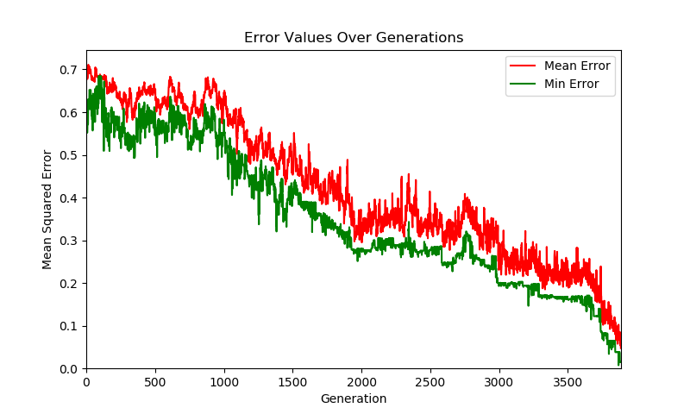
Figure 1: Performance on data set 1

However, the search space for chromosomes is very large and evolution is rather slow. As it can be seen in the following figure, it takes around 4000 generations to reduce RMSE to 0.05, which is the set target.

Increasing the probability of mutation to 0.5 and probability of crossover to 0.9 makes the GA too erratic and unable to converge.
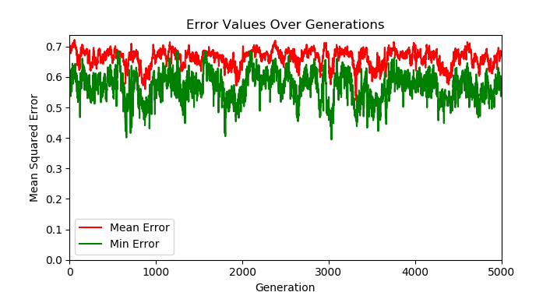
Figure 2: Performance with high rate of mutation and crossover.

This is due to too many of the population being changed randomly, that it is unable to hold the fitness. Even the fitter individuals are being eliminated and new individuals being created.

Reducing the mutation probability makes the algorithm converge to the local minima of error as no new genes are introduced and only existing ones are reproduced.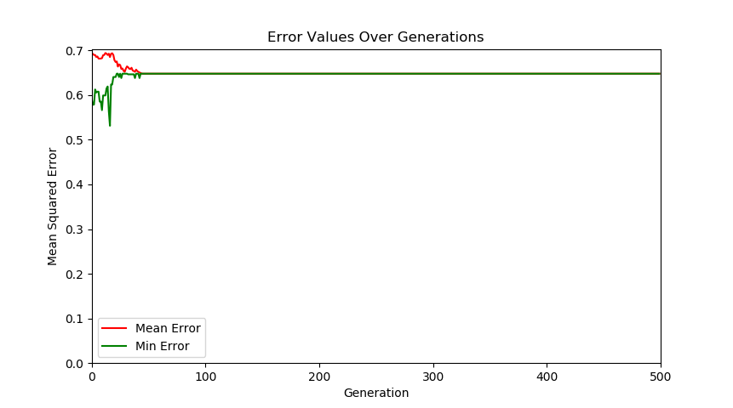
Figure 3: Result of 0 mutation rate

Reducing cross over probability has a similar effect as there is no crossover of previous generation create a fitter individual. However, as new genes are introduced by mutation, this has chance to eventually find a solution. But as the mutation is random this only amounts to a blind search.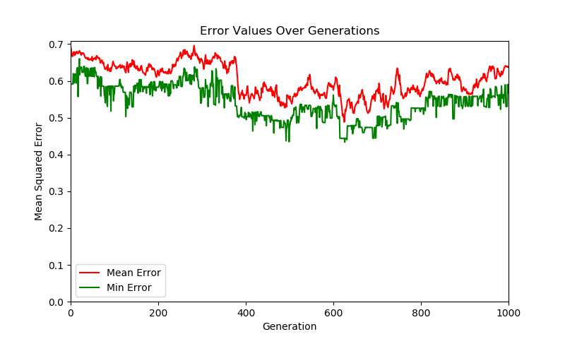
Figure 4: result of 0 crossover probability

Increasing the population size makes the algorithm more memory hungry and has no efficient increase performance. However, decreasing the population too much can reduce diversity and hence will not converge.
Figure 5: Result of doubled population

3.2 Data Set 2

Even though data set 2 is very similar to data set 1, it is larger and requires more search it take a huge amount of time to converge to a solution. As seen in the following figure, it has failed to find a solution even after 5000 generations.

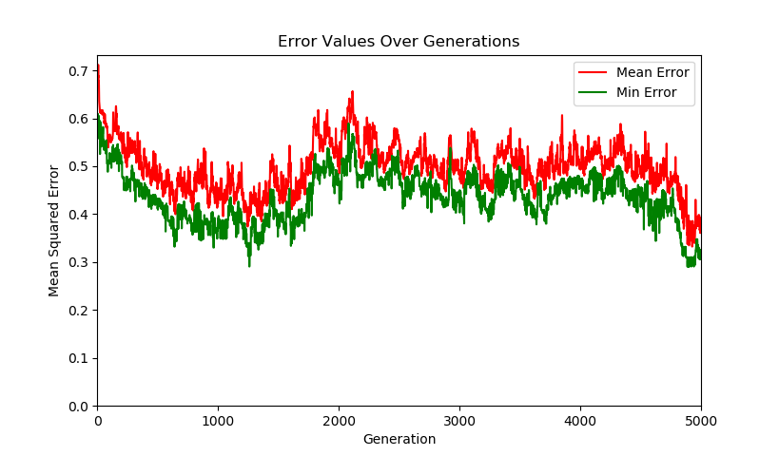
Figure 6: Initial performance of data set 2

So, another method to improve performance was introduced here. Instead of training for the entire dataset from the beginning, data was fed through batches until the network is trained for entire data set. Batches of 4 are used here, but the size of batches can be adjusted to optimize performance.

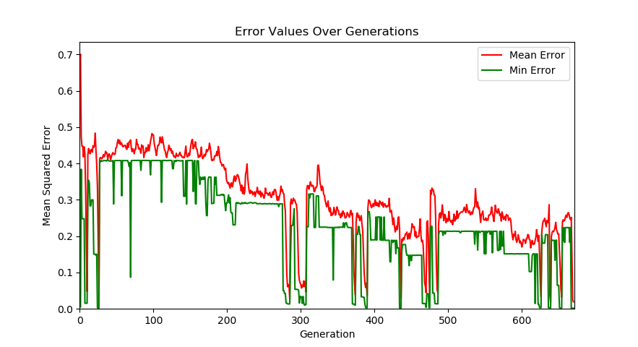
Figure 7: Performance with batch training.

As seen, the performance has increased dramatically with batch training. When one batch is trained, the new batch of data is introduced. This allows the data to converge more easily and then search within that area when new batch is introduced.

3.3 Data Set 3

The same batch training method is used for the data set 3. However, as huge amount of data is included in the data set 3 and too much data means the algorithm will require more computational power and more memory. There for only the total size trained at a time is kept at maximum 64. If the training data exceeds this the oldest data is removed.

Also, the data is divided into training and validation data, as enough data is given here that could train the network without entire data. And as the set is real valued some amount of error is acceptable to prevent over fitting.

The following diagrams show the performance of data set 3.
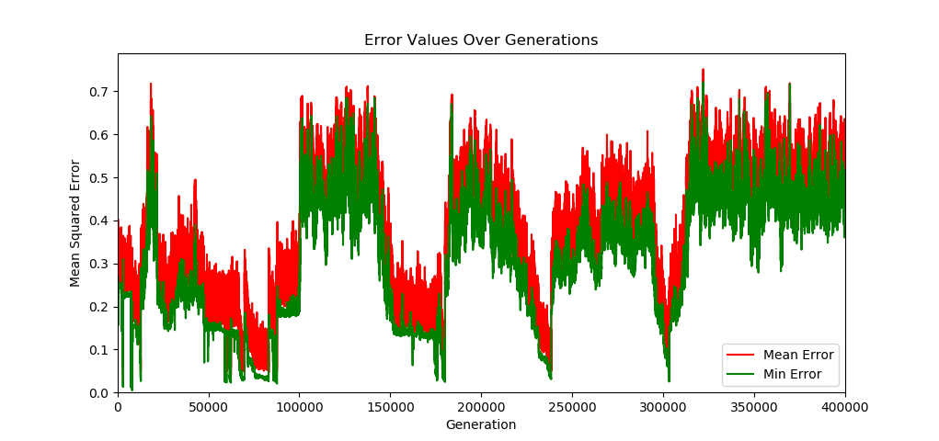
Figure 8: Training for 400000 generations

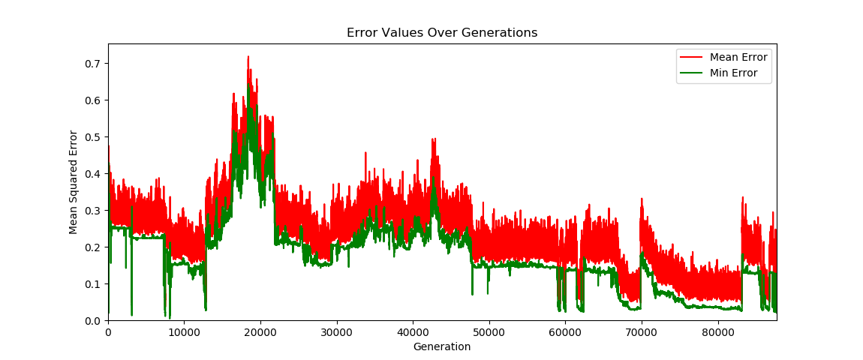
Figure 9: Training for 23 batches.

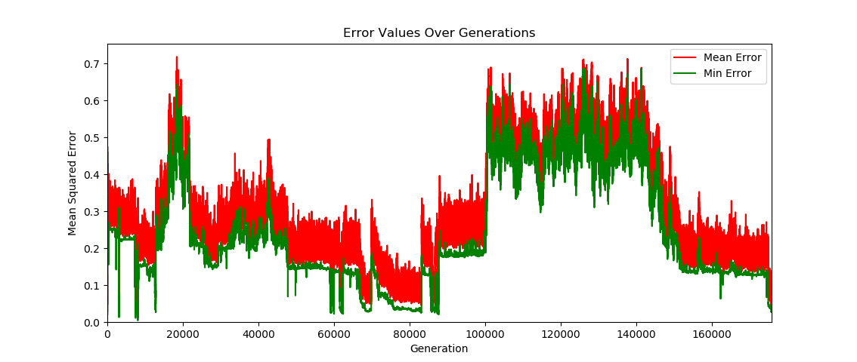
Figure 10: Training for 25 batches.

Training for this amount of data takes a lot of time, how ever from the figures above, it can be seen that the training converges and over time can be fully trained for the data.

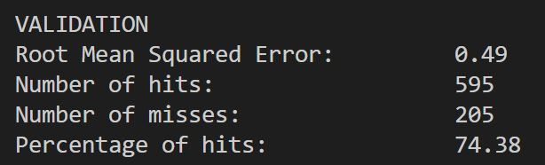

After training for 23 batches, which is less than 100 rows of data. network is able to classify approximately 75 percent of the validation data correctly. Therefore, if trained for more time, the network’s performance can improve greatly.

4 CONCLUSIONS
Although the algorithm is able to evolve to classify dataset 3, the performance very slow and not ideal. Therefore, more optimization of algorithm is required.

A more general evolutionary classification algorithm may also perform better.

Some of the things that can be tried are crossover of weights of layers or weights of neurons separately. And mutation to create fitter genes.

Also, the NEAT approach can be more efficient, although it will be more complex to implement.

REFERENCES
Karpov, P., Squillero, G. and Tonda, A. (2018) VALIS: an evolutionary classification algorithm. Genetic Programming and Evolvable Machines. 19 (3), pp. 453–471. doi:10.1007/s10710-018-9331-6.
Liu, R., Zhang, P., Jiao, L. and Li, Y. (2012) Supervised immune clonal evolutionary classification algorithm for high-dimensional data. Neurocomputing. 98 pp. 123–134. doi:10.1016/j.neucom.2011.08.044.
Panda, M. and Abraham, A. (2015) Hybrid evolutionary algorithms for classification data mining. Neural Computing and Applications. 26 (3), pp. 507–523. doi:10.1007/s00521-014-1673-2.
Stanley, K.O. and Miikkulainen, R. (2002) Evolving Neural Networks through Augmenting Topologies. Evolutionary Computation. 10 (2), pp. 99–127. doi:10.1162/106365602320169811.
Tan, P.-N., Steinbach, M. and Kumar, V. (2005) Introduction to Data Mining, (First Edition). Boston, MA, USA: Addison-Wesley Longman Publishing Co., Inc.

The algorithm can be found here.
https://github.com/lmbmabdullah/EvolutionaryNeuralNetwork

